FROM: Charity Nduhura (APM) | TO: Dorothy M. Tuma (Director), Board Members
 | DATE: 5ᵀͪ November 2018
SUBJECT: October2018 Report
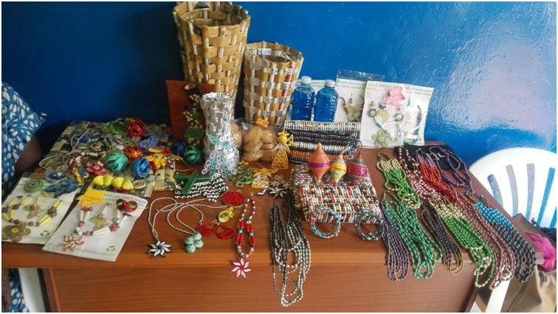Some of the products made by WiB participants

Achievements

1.1 Women in Business (WiB) follow-up Coaching
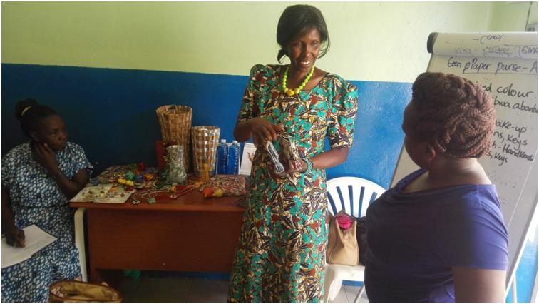Agatha one of the WiB participants explains her paper purse characteristics

Following the 3rd Quarter WCFJC Women in Business (WiB) Workshop held on Wednesday 29thAugust 2018, a one-day follow-up coaching session was conducted for twelve (12) Group two participants comprised of: CORE, Biyinzika and Kwagala Women's Groups on 26th October 2018 at WCFJC's Office plot 48 main street.

The objective of the coaching session was to review product characteristics and marketing of products and services to help in evaluation and alignment of products to customer expectations.

The session began with a recap of what was covered during the quarterly workshop, followed by an interactive session where participants discussed product characteristics using their products and services.

In the recap participants were asked the 5Ps they could remember; these included product, price, people, place and promotion. The coach identified product as the main “P” and emphasized that all other Ps rotated around the product.

The Product characteristics included; size, color, texture, smell/aroma, spices, packaging, labeling, quality, time, cost.

The coach explained all the characteristics urging participants to try their best to meet customers' expectations in all the aspects for example using attractive colors, on time delivery and considering all expenses to arrive at the final cost price.

The business Coach further demonstrated product characteristics using her cookies;
Color - Cream
Size - Medium
Shape - Oval
Cost - 1,000/- a pack
Quality - solid
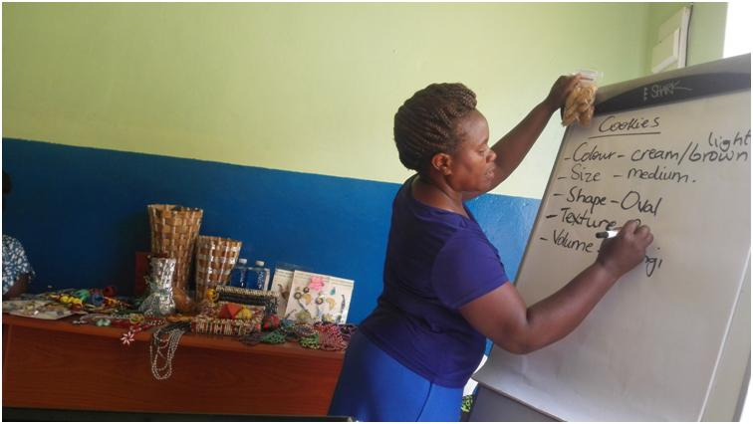 Business Coach (Harriet) explaining product characteristics using her cookies

Some of the participants then discussed their product characteristics using samples of their products.

Caroline Okurut- Paper jewelry
Caroline explained characteristics of her paper Necklace
Color - attractive
Size - medium
Texture - smooth on the skin

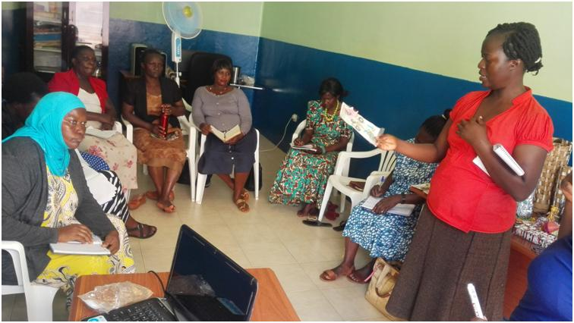Caroline explaining her paper necklace characteristics

Agatha Christine Odongo - Paper bead products
Agatha took fellow participants through characteristics of her paper bead products using her paper bead purse;
Color - mixed attractive colors, liked by many customers
Size - Medium to carry ladies make up
- Small for coins and keys
- Large for phones, keys
- Messenger/extra large for books to school, luggage, shopping, etc
Shape - Rectangular for small and medium, oval for extra size / shopping bags.
Quality - Strong material
Time - Can be delivered in one day
Cost - Price is fair, costs considered include cost of papers, glass beads, papers, fishing line, zippers, fabric and varnish.
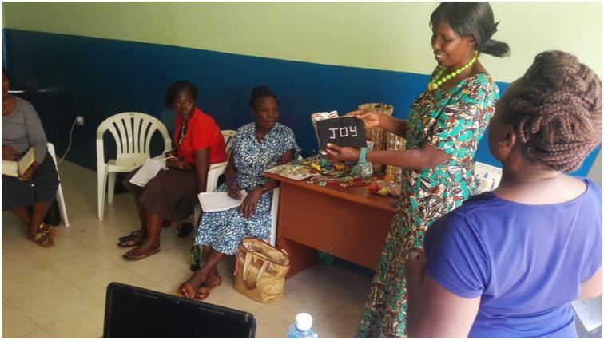Agatha explaining her paper purse characteristics

Evelyn Mawubanya - liquid soap
Evelyn representing CORE Development group explaining characteristics of the CORE group liquid soap;
Color - blue to make it unique from the watery green known by clients sold by hawkers
Volume - 600mls, 1literbottle, 5 liter jerrycan and 20 liter jerrycan.
Shape - cylindrical
Quality - good and thick enough not watery
Time - two days to make 40 liters
Cost - cost is derived from cost of labor and materials.

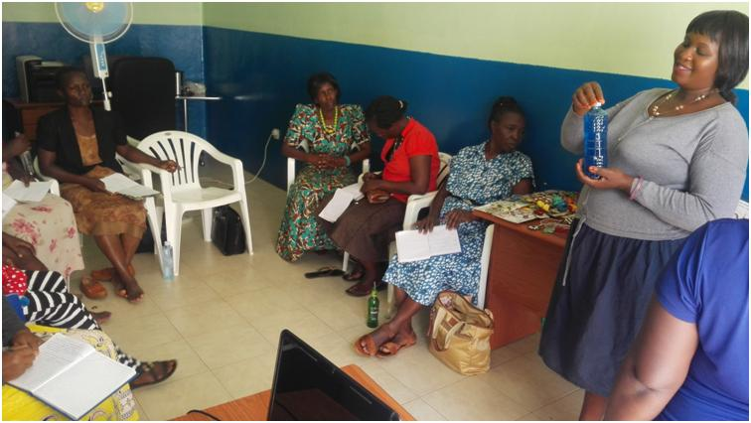Evelyn explaining characteristics of the group liquid soap

The business coach (Harriet) concluded by explaining the importance of product characteristics in marketing. She emphasized that knowing your customer and their expectations in terms of product characteristics will help you design the right product for your customers.

1.2 WCFJC Annual Report 2017/2018
The draft WCFJC annual report for 2017/2018 has been written and submitted to the Director for review. The final copy will be ready by end of November and uploaded on the WCFJC Website.

1.3 Phase VIII WiB in-kind Loan Repayment
Seven (8) out of the Nine (9) Phase VIII WiB participants who received in-kind loans on 15th December 2017 paid back the loan. The remaining one (1) beneficiary got challenges with paying back due to her stock that was stolen from a taxi. She promises to payback when she recovers from the loss. By 30thOctober 2018,the repayments totaled to UGX3,748,500 equivalent to (98%) loan portfolio recovery from UGX 3,691,000 (96%) in September 2018 (Ref: Appendix III).

Note: WCFJC team is revising loan disbursement policy and considering recruitment of more participants before embarking on another loan phase in early 2019. Participants' savings accumulated in the two phases will be given back to them for reinvestment through the season without loans. Below are the participants’ savings accumulated in the two phases.

Phase | Savings (Amount)
VIII | 703,000
VII | 836,500
Total | 1,539,500

2.0 Upcoming Activities for the month of November 2018
- Giving back WiB participants savings.
- Conducting Women in Business follow-up coaching for the 4thQuarter Workshop, scheduled to take place on 29th November 2018.
- Finalizing WCFJC Annual report.
Appendix I: Summary of Financial Requirements for November2018
Item | Cost (UGX)
Office Petty Cash(October) | 20,000
APM Lunch (October) | 100,000
WiB Quarter training(November 2018) and office stationery | 291,000
APM internet | 129,000
WCFJC Office rent (October, November, December) | 1,200,000
WiB participants savings | 1,539,500
Total | 3,279,500

Appendix II
Budget for Women in Business 4thQuarter Workshop scheduled for 21st November 2018 and office stationery.
No. | Item | Quantity | Rate (UGX) | Amount
1 | Transport (Materials) to & from the Venue | 1 | 10,000 | 10,000
2 | Lunch | 16 | 6,000 | 96,000
3 | Venue Hire | 1 | 80,000 | 80,000
4 | Flip chart | 2 | 18,000 | 36,000
5 | A box of markers | 1 | 10,000 | 10,000
6 | Ream of papers | 1 | 18,000 | 18,000
7 | A box of pens | 1 | 23,000 | 23,000
8 | A dozen of note books | 1 | 18,000 | 18,000
 | Total |  |  | 291,000

LOAN DISBURSMENT DATE | REPORTING MONTH | LOAN PHASE | LOAN PORTFOLIO UGX | ACTUAL LOAN AMOUNT RECOVERED | BORROWER SAVINGS | #ACTIVE LOANS | #WEEKS IN LOAN PHASE | %LOAN PHASE COMPLETED | %LOAN PORTFOLIO RECOVERED | % COMPLIANT BORROWERS
25th Nov- 15thDec 2017 | October2018 | Phase VIII | 3,840,000 | 3,748,500 | 703,000 | 01 | 14 | 100% | 98% | 89%
Appendix III

