FROM: Charity Nduhura (APM) | TO: Dorothy M. Tuma (Director), Board Members
 | DATE: 4thAugust 2018
SUBJECT: July 2018 Report
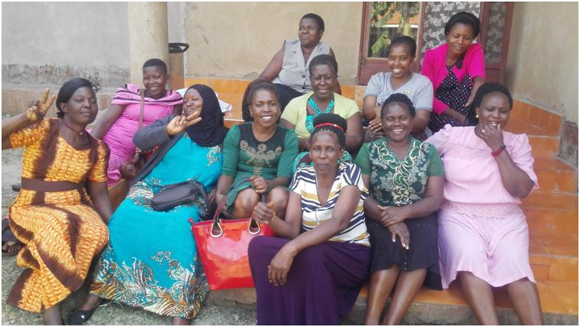Group photo of participants and the Business Coach

Achievements
1.1 Women in Business (WiB) Follow-up Coaching
Following the WiB Quarterly Workshop held on 9thMay 2018, a one-day follow-up coaching session was conducted for twelve (12) Group 2 participants comprised of: CORE, Biyinzika and Kwagala Women's Groups on 25th July 2018 at Ms. Jennifer Sempa's home in Mpumudde Sub-county, Jinja District.

The objective of the coaching session was to review Market Development and Marketing of products and services.

The session began with a recap of what was covered during the quarterly workshop. In an interactive session, participants discussed the marketing mix using their businesses as case studies.

Marketing-mix
1) Product - Something to be sold
2) Place - Premises where products or services are sold
3) Price - The value the product is sold at (mostly monetary value)
4) Promotion - Making potential customers aware of the product or service
5) People - Sales people and clients/customers.

Marketing-mix - Business Coach
The Business Coach (Harriet) used tomatoes from her gardens to give an example of marketing mix.
a) Product - Tomatoes
b) Price – UGX. 1,000
c) Place - Makenke and Gayaza
d) Promotion - Brokers, sign post and word of mouth
e) People - Harriet is the seller, wholesalers, retailers, women and men are the clients.
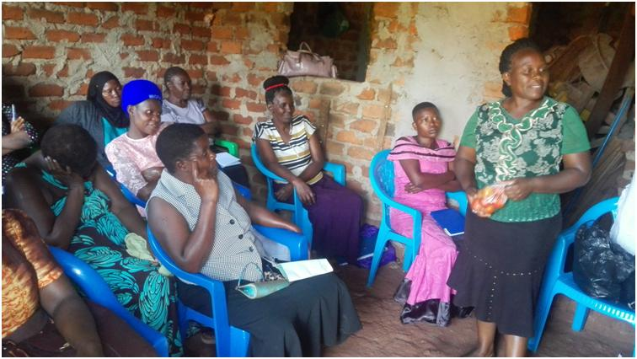Business Coach (Harriet) reviewing marketing mix using her tomatoes

Some of the participants discussed the marketing mix for their businesses as shown below:
- Agatha Odongo Christine
a) Product - Bags, necklaces, earrings, wallets, belts among others
b) Price – UGX10,000 - UGX 80,000
c) Place - Walukuba, churches, conferences and at other gatherings
d) Promotion - Business cards, social media, word of mouth.
e) People - Agatha is the seller and tourists are the buyers

- Jenifer Sempa
a) Product - Kumbucha health drink
b) Price – UGX 1,000 - UGX 20,000
c) Place - Mpumudde and to women groups
d) Promotion – Word-of-mouth, business cards, labels and social media
e) People - Jenifer is the seller, shops and individuals are the clients
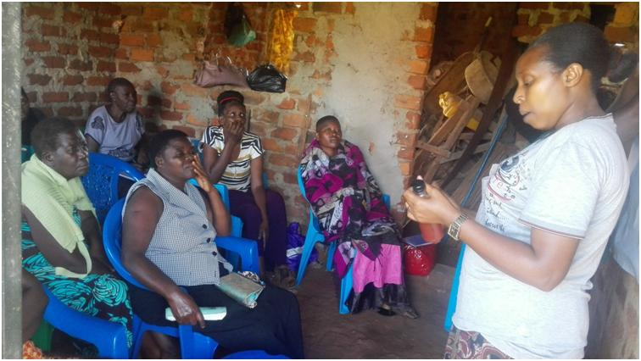Jenifer with her kumbucha drink, presenting her marketing mix
- Mary Namwase
a) Service - Tailoring
b) Product - Ebitengi, gomesi, uniforms
c) Price – UGX 35,000
d) Place - Namulesa and among women groups in the communities
e) Promotion – Mary's and her children’s attire, word-of-mouth, hawking
f) People - Mary is the seller, women and men are the clients

- Hasifa Sajjabi
a) Service - Catering
b) Price – UGX100,000 - UGX 1,000,000
c) Place – Parties, funerals, schools, churches, individual homes among others
d) Promotion – Word-of-mouth by satisfied customers, t-shirts, business cards and branded table cloth
e) People - Hasifa, her children and staff are sellers, buyers are schools, families, projects among others.

The Business Coach finalized by emphasizing production of what customers want to buy versus what producers want to sell.

1.2 Profiling Participants
The profiling and documentation of the results of WiB Participants started and 10 participants have been profiled in July 2018. This is done to follow up and document WiB programme achievements.
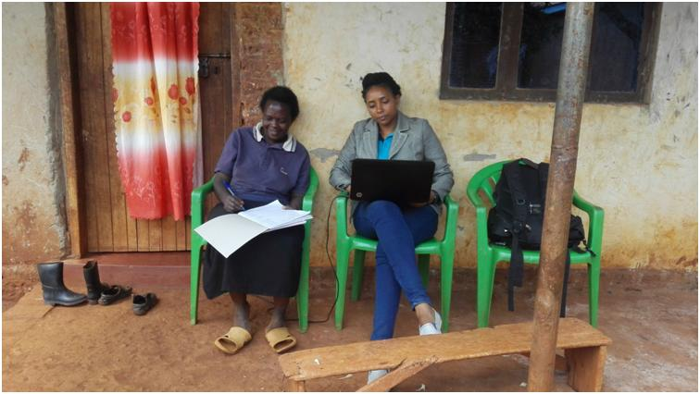WCFJC APM capturing Sarah's profile one of the WiB Participants
1.3 Phase VIII WiB in-kind Loan Repayment and Savings
The Phase VIII WiB participants who received in-kind loans on 15thDecember 2017continue to pay back their loans. By 31stJuly 2018, the repayments totaled to UGX 3,391,500 (88% loan portfolio recovered) from UGX 2,655,000 (69%) in June and the savings amounted to UGX 703,000 from UGX 666,000 in June (Ref: Appendix III).

3.0 Upcoming Activities for the month of August 2018
- Profiling ten participants – document activities and outputs for the target participants.
- Collection of outstanding loan repayments for six participants under Phase VIII WiB Loan.
- Conduct Women in Business3rd Quarter Workshop, scheduled to take place on 29th August 2018.

Appendix I: Summary of Financial Requirements for August2018
Item | Cost (UGX)
Office Petty Cash(July) | 20,000
APM Lunch (July) | 100,000
QuarterlyWorkshop (August 2018) | 306,000
Jinja office rent (July, August, September) | 1,120,000
APM Internet (28th August 2018 - 28th November 2018 | 129,000
Total | 1,675,000

Office rent has been reduced from UGX 440,000 to UGX 400,000 per month, effective May 2018. UGX 80,000 which was paid in excess for May and June has been carried forward thus the need to pay a reduced amount of UGX 1,120,000 instead of UGX 1200,000 for the next three months (July, August and September 2018).

Appendix II
Budget for Women in Business 3rd Quarter Workshop scheduled for 29th August 2018
No. | Item | Quantity | Rate (UGX) | Amount
1 | Transport (Materials) to & from the Venue | 1 | 10,000 | 10,000
2 | Lunch | 16 | 6,000 | 96,000
3 | Venue Hire | 1 | 80,000 | 80,000
4 | Trainers’ fees (Transport 20,000 and 100,000 training fees) | 1 | 120,000 | 120,000
 | Total |  |  | 306,000

LOAN DISBURSMENT DATE | REPORTING MONTH | LOAN PHASE | LOAN PORTFOLIO UGX | ACTUAL LOAN AMOUNT RECOVERED | BORROWER SAVINGS | #ACTIVE LOANS | #WEEKS IN LOAN PHASE | %LOAN PHASE COMPLETED | %LOAN PORTFOLIO RECOVERED | % COMPLIANT BORROWERS
25th Nov- 15thDec 2017 | July 2018 | Phase VIII | 3,840,000 | 3,391,500 | 703,000 | 06 | 14 | 100% | 88% | 33%
Appendix III

