FROM: Charity Nduhura (APM) | TO: Dorothy M. Tuma (Director), Board Members
 | DATE: 4th September 2018
SUBJECT: August 2018 Report
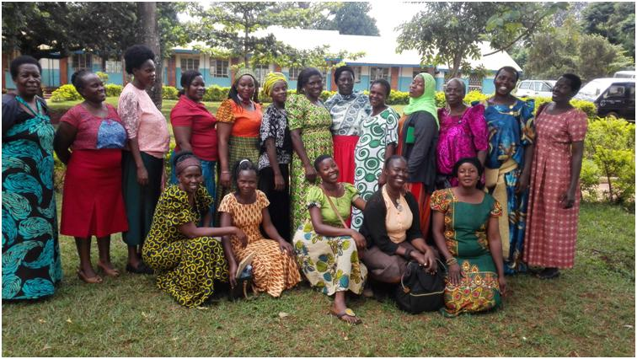Group photo of participants with the Business Coach

Achievements

Women in Business 3rd Quarter Workshop
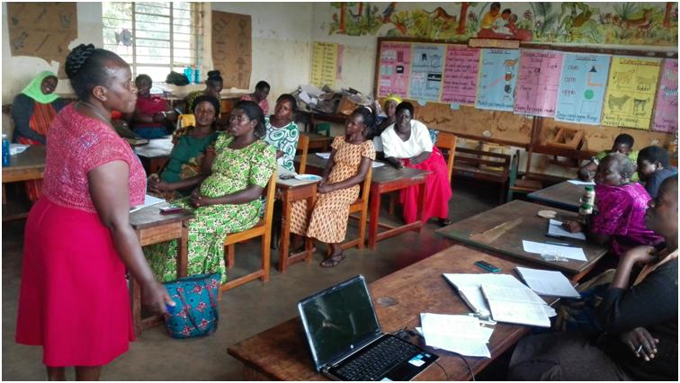
Business Coach (Harriet) facilitating the workshop

The 3rd Quarter WCFJC Women in Business (WiB) Workshop was held on Wednesday 29th August 2018 at St. Nicholas Primary School, Jinja.

The workshop focused on product characteristics and Marketing, it was attended by 17 WiB participants facilitated by the WCFJC Business Coach, Ms. Harriet Nsubuga..

The objective of the training was to engage participants in evaluation and alignment of products they put on the market for the customers.
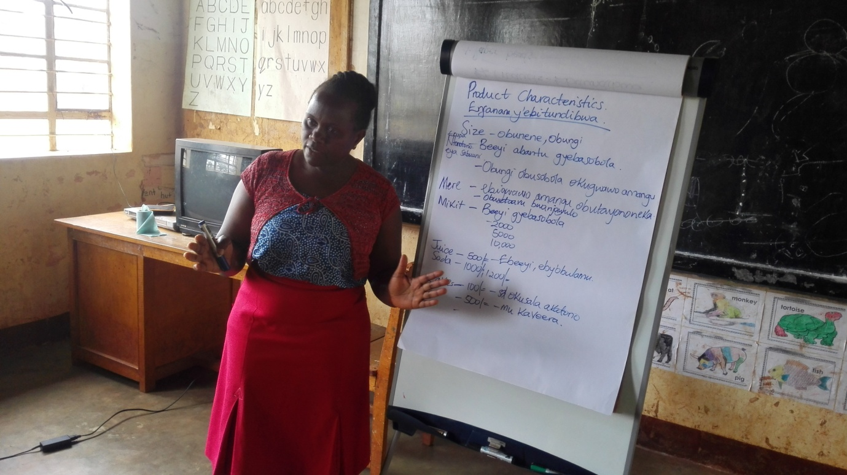Business Coach (Harriet) explaining product characteristics
Aspects considered included;
1. Quantity and Size
Both quantity and size of products/services should be affordable to the target client, for example having a smaller glass of juice of about UGX 2,000 for low income earners and also a bigger glass of UGX5,000 and above for those who can afford. She emphasized that both size and quantity of every product should be put into consideration for client satisfaction.
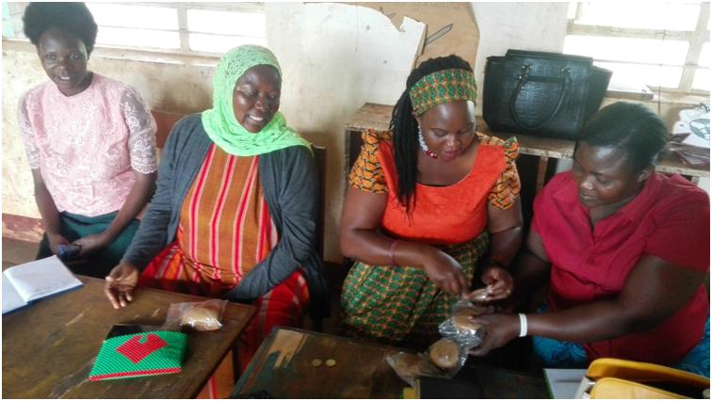Evelyn sales cakes she bakes to the participants
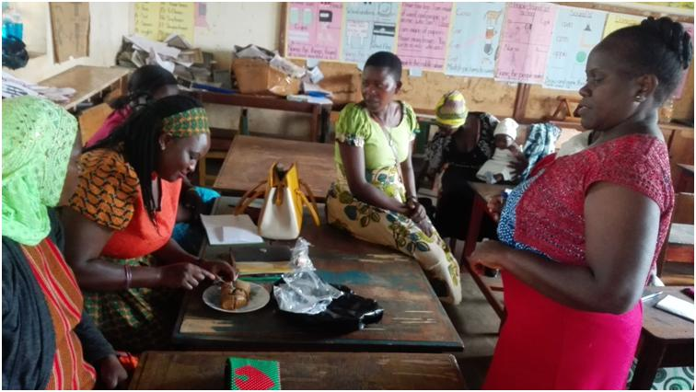Evelyn demonstrates how she cuts the cakes into small pieces of UGX 100 to cater for all clients
2. Product color
The color of the product should match customer expectations for instance liquid soap is known to be green or blue so giving it a yellow color might not attract clients thinking it might not be fit for purpose. Fruit juice is known to be either yellow or orange depending on the type of the fruit, so making it blue or green if it is not herbal can raise concern among customers. This calls for market research to know customers/clients expectations before production of the products/services.

3. Smell/flavor/aroma of the product
The aroma of the product should be appealing and seductive enough to attract clients for example lavender, rose, among others in soap, perfumes, Vaseline among others.

4. Ingredients
For drinks, natural flavors, herbal, mixed fruits in drinks, and in cooked food the type of curry used, materials used, labeling requirements - Q or S mark, size of font, pictures to use all contribute to customer satisfaction and should be taken care of.

5. Quality
Quality is key in production of any product. In addition to meeting customers' expectations, required standards for example UNBS, Global GAP, health standards in foods and drinks among others must be met. This is for compliance with authorities and protection of the clients against harmful products.

6. Time
Production and delivery to the clients should be done timely. Delivery time should be adhered to, duration in terms of frequency of product delivery(daily, weekly or monthly). The supply should be consistent to avoid losses in terms of stock out costs and goodwill.

7. Product Costing
Proper costing must be done to gain from any product and to avoid making losses.
Some of the determinants of costs are:
1. Cost of raw materials for one piece e.g. a drink, a cake, address.
2. Cost of labor– staff/workers both full time and casual, own labor.
3. Cost of machinery/equipment - drier, blender, sewing machine, saucepans, desks and chairs.
4. Cost of utilities - electricity, water, gas, firewood.
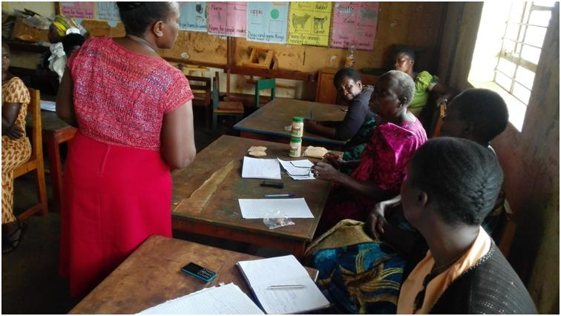Florence explaining ingredients used in preparation of her Mikit product
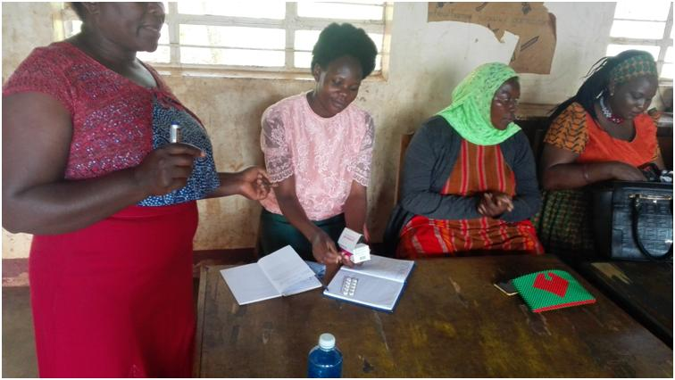Peninah running a drug shop demonstrating one of the products (Paracetamol)
1.2 Profiling Participants
The profiling and documentation exercise of the results of WiB participants has been completed. The exercise was done to follow up and document WiB programme achievements. The profiles will continually be updated to have current detailed information about the program participants.

1.3 Phase VIIIWiB in-kind Loan Repayment
Six (6) out of Nine (9) Phase VIII WiB participants who received in-kind loans on 15th December 2017 have completed paying back. The remaining three (3) will be completing paying back by the end of September 2018. By 31stAugust 2018, the repayments totaled to UGX 3,622,500 equivalent to (94%) loan portfolio recovery from UGX 3,391,500 (88%) in July 2018. (Ref: Appendix III).

3.0 Upcoming Activities for the month of September 2018
- Collection of outstanding loan repayments for three participants under Phase VIII WiB Loan.
- Conduct Women in Business follow-up coaching for the 3rd Quarter Workshop, scheduled to take place on 19th September 2018.
- Writing of the WCFJC Annual report.
Appendix I: Summary of Financial Requirements for September 2018
Item | Cost (UGX)
Office Petty Cash(August) | 20,000
APM Lunch (August) | 100,000
Field transport (Profiles compilation) | 150,000
Follow up coaching(September 2018) | 64,000
Total | 334,000

Appendix II
Follow-Up Coaching Lunch Budget ( September 2018) for 12 Participants
Item | Units | Unit cost | Amount
Meat | 2kgs | 10,000 | 20,000
Rice | 3kgs | 3,000 | 9,000
Matooke | 1 bunch | 25,000 | 25,000
Charcoal | 1 basin | 10,000 | 10,000
Total |  |  | 64,000

LOAN DISBURSMENT DATE | REPORTING MONTH | LOAN PHASE | LOAN PORTFOLIO UGX | ACTUAL LOAN AMOUNT RECOVERED | BORROWER SAVINGS | #ACTIVE LOANS | #WEEKS IN LOAN PHASE | %LOAN PHASE COMPLETED | %LOAN PORTFOLIO RECOVERED | % COMPLIANT BORROWERS
25th Nov- 15thDec 2017 | August 2018 | Phase VIII | 3,840,000 | 3,622,500 | 703,000 | 03 | 14 | 100% | 94% | 67%
Appendix III

