FROM: Charity Nduhura (APM) | TO: Dorothy M. Tuma (Director), Board Members
 | DATE: 4thOctober2018
SUBJECT: September 2018 Report
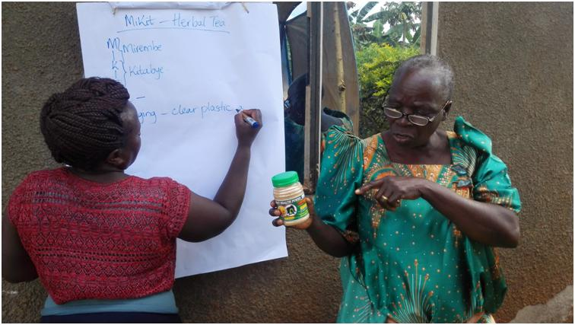Florence explaining the components of her product

Achievements

1.1 Women in Business (WiB) Follow-up Coaching
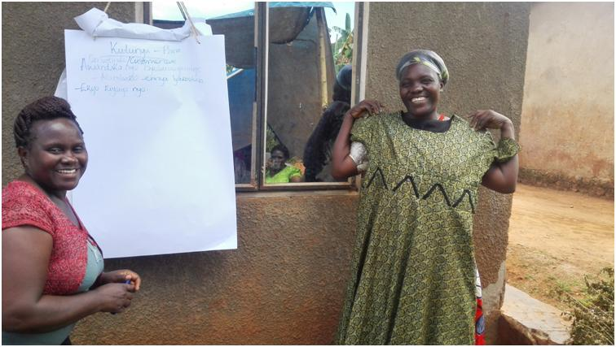Fina displaying one of her products
Following the 3rd Quarter WCFJC Women in Business (WiB) Workshop held on Wednesday 29th August 2018, a one-day follow-up coaching session was conducted for nine (9) Turikilala group participants on 21st September 2018 at Ms. Hagira Kawala’s home in Budondo Sub-county, Jinja District.

The objective of the coaching session was to review product characteristics and marketing of products and services to help in evaluation and alignment of products with customer expectations.

The session began with a recap of what was covered during the quarterly workshop, followed by an interactive session of participants discussing product characteristics using their products and services.

In the recap some of the services talked about included catering, teaching and tailoring. Briefly the business couch (Harriet)explained to participants that what distinguishes services from products is their intangibility nature or characteristic.

The characteristics of the products discussed included: size, quantity, colour, scent, quality, time, cost, among others. Examples given in relation to characteristics included:
Baking cakes of different sizes and affordable to different customers for example cakes for UGX. 100, UGX.500 and UGX.1000; Soap that is expected to be blue or green, oils in pink not black and with attractive scent; White fabrics for men, green and brown for women; Uniforms in blue, red, black and polyester for quick drying; Quality and quantity for example big eggs with yellow yoke are preferred; Time is a big factor in any business, production and delivery time must be put into consideration. Lastly the cost of the product must be determined to arrive at the selling price and avoid high expenditure than income.

Some of the participants discussed using their products and services.

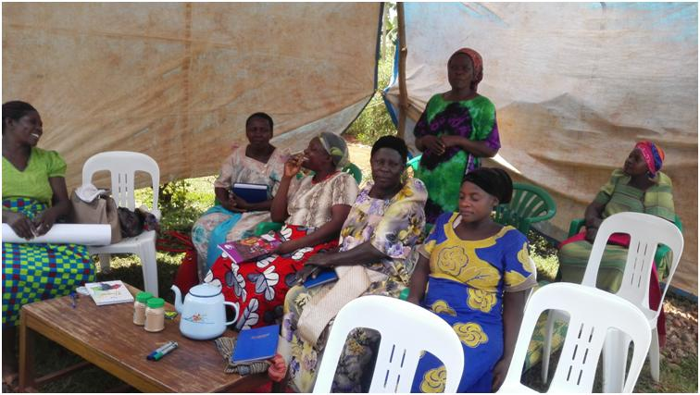Sarah explaining her tent hire service
Sarah Majimbi
Sarah bought a blue and white tent because of dust in the village, she would have preferred awhite tent but considered the environment it will be operating under. The tent is a small size for easy set up and affordable to her customers. The demand is high since a small tent is used at different functions ranging from small baptism and graduation parties to burial ceremonies. It can be easily fixed in a small compound or compound with trees, cleaned and uniquely set up.

Sarah is a water vendor who has progressed from just selling water to hiring plastic chairs and tents. She is looking forward to growing her business into an events management company with all required equipment at a function.

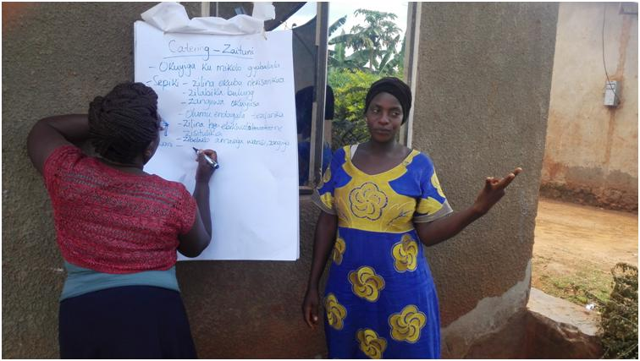Zaituni explaining her catering service

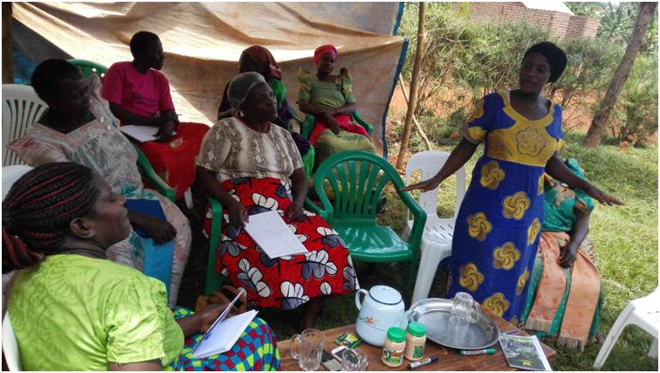

Zaituni Mukembo
Zaituni bought big saucepans with handles for easy movement from one place to another and covers to keep customers' food safe from contamination. Zaituni moves with her metallic cooking stones to the venue to avoid inconvenience. She bought different types of plates for different categories of guests, for example melamine plates for children to avoid losses in broken plates. Zaituni made uniforms for different functions; black t-shirts for burial ceremonies, white and Red for wedding parties, purple and brown for graduation or introduction parties and for marketing purposes all t-shirts are branded with her business name and contacts.

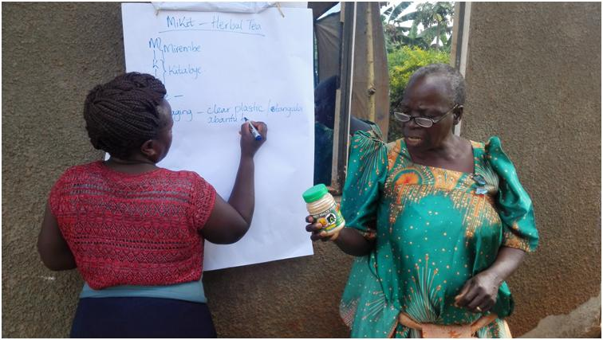Florence explaining components of her Mikit product
Florence Kitabye
Florence mills jackfruit and avocado seeds into nutritious powder, she packs in clear plastic containers for customers to see the product, with a label detailing information about the ingredients/components of the product, the colour of the label and fruits are green which is the colour expected by the customers. Florence packs in three different sizes to cater for all the customers. She was initially packing packets of UGX. 1,000 before WCFJC, but later progressed after joining WCFJC to packing in containers costing UGX. 5,000 and UGX.10,000. She is now working on securing a license from Uganda National Bureau of Standards (UNBS)to expand her market by supplying supermarkets and different shops in town.

The business Coach concluded the demonstration using tomatoes from her garden as one of her products. The tomatoes included the ripe ones and big size for immediate consumers and tomatoes not ripe enough for take home customers. The parks are small and affordable to the customers.

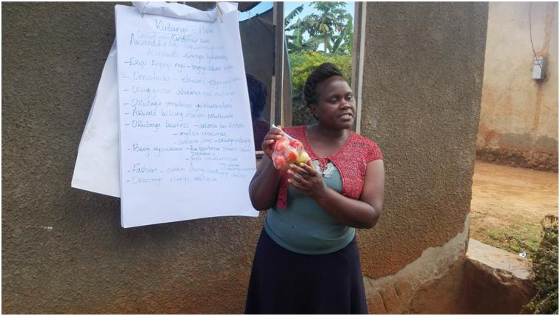Harriet- Business Coach explaining product characteristics using her tomatoes

1.2 Visit by Susan Warshauer, Board Chair and Julia Pettengill, Executive Director African Food and Peace Foundation
WCFJC hosted Susan and Julia from African Food and Peace Foundation, Boston on 28thSeptember 2018. They visited four (4) of the WiB participants including: Hasifa Sajabbi, Mary Namwase, Sarah Majimbi and Florence Kitabye because of limited time. Susan and Julia were grateful to WCFJC for the work done in empowering women. Profiles of 10 of the WiB participants were also prepared and shared with the visitors to get a clear picture of what WCFJC does. .
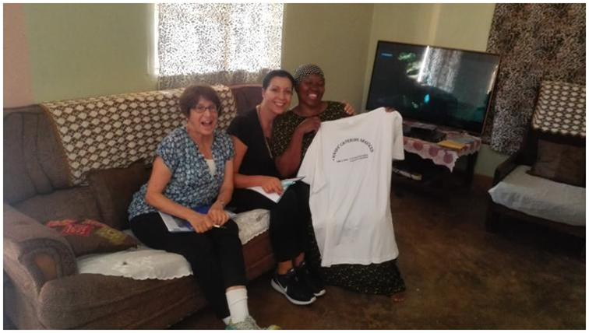Susan and Julia visiting Hasifa
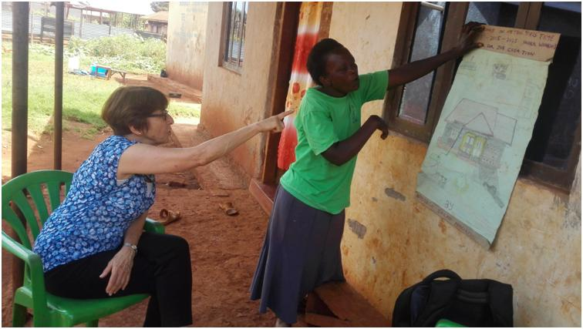Sarah explaining her 10year vision
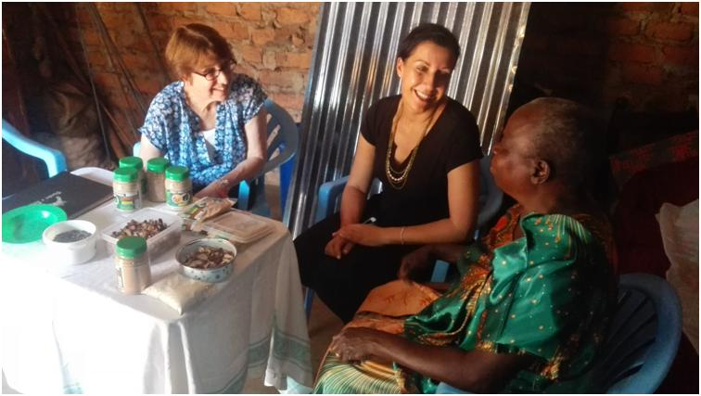Susan and Julia visiting Florence
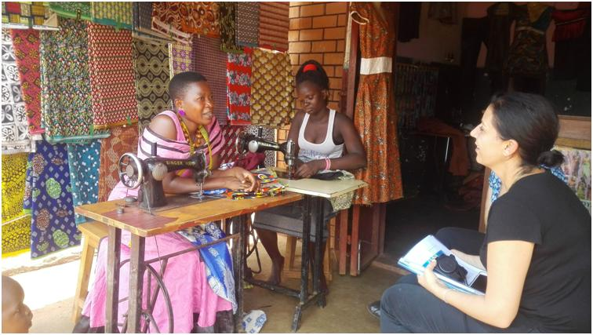Mary telling her success story

1.3 Phase VIII WiB in-kind Loan Repayment
Seven (7) out of the Nine (9) Phase VIII WiB participants who received in-kind loans on 15thDecember 2017 have completed paying back. The remaining two (2) will be completing paying back by the end of October 2018. By 30th September 2018, the repayments totaled to UGX3,691,000 equivalent to (96%) loan portfolio recovery from UGX 3,622,500 (94%) in August 2018.(Ref: Appendix III).

2.0 Upcoming Activities for the month of October 2018
- Collection of outstanding loan repayments for the two remaining participants under Phase VIII WiB Loan.
- Conduct Women in Business follow-up coaching for the 3rdQuarter Workshop, scheduled to take place on 31stOctober2018.
- Writing of the WCFJC Annual report.
Appendix I: Summary of Financial Requirements for October 2018
Item | Cost (UGX)
Office Petty Cash(September) | 20,000
APM Lunch (September) | 100,000
Follow up coaching(October 2018) | 64,000
Total | 184,000

Appendix II
Follow-Up Coaching Lunch Budget ( October 2018) for 12 Participants
Item | Units | Unit cost | Amount
Meat | 2kgs | 10,000 | 20,000
Rice | 3kgs | 3,000 | 9,000
Matooke | 1 bunch | 25,000 | 25,000
Charcoal | 1 basin | 10,000 | 10,000
Total |  |  | 64,000

LOAN DISBURSMENT DATE | REPORTING MONTH | LOAN PHASE | LOAN PORTFOLIO UGX | ACTUAL LOAN AMOUNT RECOVERED | BORROWER SAVINGS | #ACTIVE LOANS | #WEEKS IN LOAN PHASE | %LOAN PHASE COMPLETED | %LOAN PORTFOLIO RECOVERED | % COMPLIANT BORROWERS
25th Nov- 15thDec 2017 | September 2018 | Phase VIII | 3,840,000 | 3,691,000 | 703,000 | 02 | 14 | 100% | 96% | 78%
Appendix III

More pictures of Susan and Julia's visit to WCFJC
